**Step1 : Describe services**

# kubectl get replicationcontroller

# kubectl expose replicationcontroller nginx-www --type="LoadBalancer"

# kubectl describe service nginx-www

**Step2 : Describe pods**

# kubectl get pods

**Step 3 : Login to each of pod and edite index.html file and name web-01, web-02,web-03 respectively**

kubectl exec -it nginx-www-8vv4w /bin/bash

apt update && apt install vim -y

vim /usr/share/nginx/html/index.html

exit

**Repeat above steps on other two containers**

kubectl exec -it nginx-www-drsgr /bin/bash

kubectl exec -it nginx-www-w8k7s /bin/bash

**Step 4 : Note down your cluster ip**

kubectl get services nginx-www

**Step 5 : create a container ,login to access web via curl**

kubectl run busybox1 --generator=run-pod/v1 --image=yauritux/busybox-curl --restart=Never --tty -i

Repeat below steps multi times and observer requests come from different containers

curl http://<Ip Address>:80

You should get web page various containers

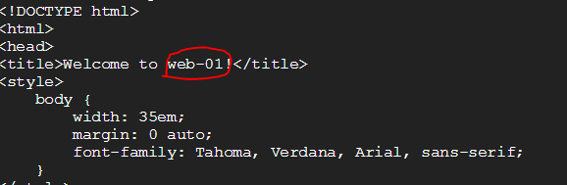

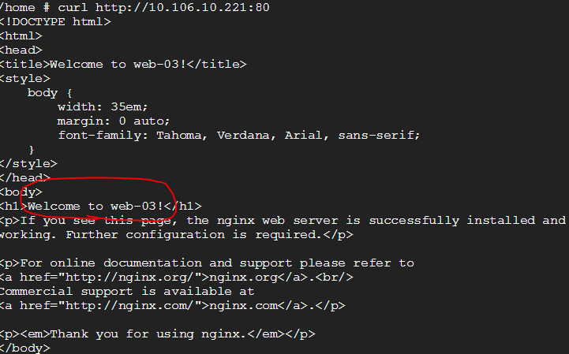

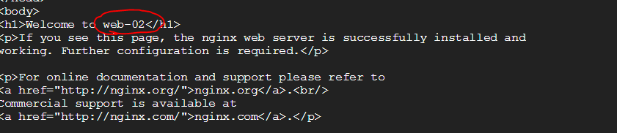

**Step 6:List all the pods**

# kubectl get pods

**Step7 :Delete the particular pod which you want**

# kubectl delete pod nginx-www-2s3pz

**Step 8 :List all the pods which is currently present( will regenerate the pod)**

# kubectl get pods

**Step 9 :Delete the particular pod**

# kubectl delete pod nginx-www-o7a0b

**Step 10 :list the pods and check fo the previous pod**

# kubectl get pods

**Step 11 :Get the details about replicationcontroller**

# kubectl get replicationcontroller

**Step 12 :Now delete the replicationcontroller**

# kubectl delete replicationcontroller nginx-www

**Step 13 :Now list the pods(Those the pods will be deleted)**

# kubectl get pods